Chapter 10: Correlation and Regression
Sections 10.1 – 10.3: CORRELATION AND REGRESSION

A correlation exists between two variables when one of them is related to the other in some way.

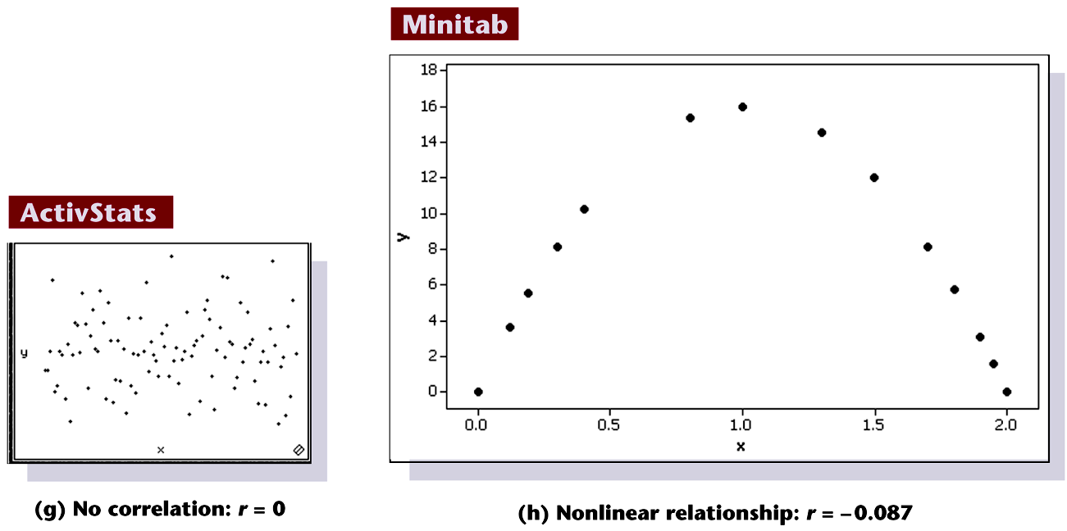

Scatterplots of paired data

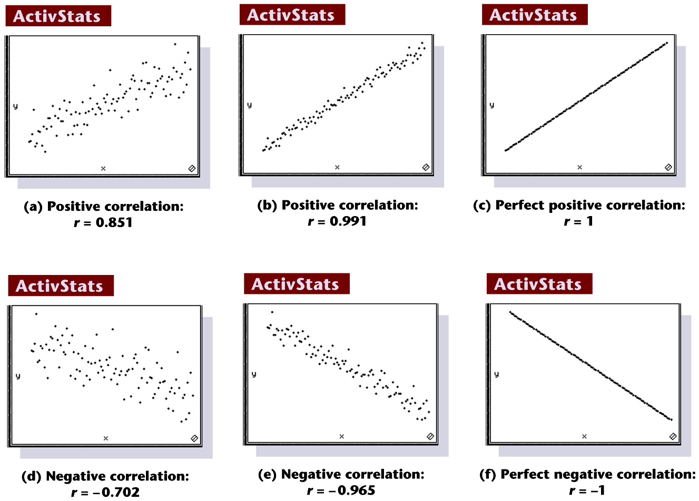

The linear correlation coefficient r measures the strength of the linear relationship between paired x- and y- quantitative values in a sample.

The key concept of this section is to describe the relationship between two variables by finding the graph and the equation of the straight line that best represents the relationship.

The straight line is called a regression line and its equation, expressed in the form y = b₀ + b₁x, where b₀ is the y-intercept and b₁ is the slope, is called the regression equation.

NOTATION:

n represents the number of pairs of data present.
Σ denotes the addition of the items indicated.
Σx denotes the sum of all x-values.
Σx2 indicates that each x-value should be squared and then those squares added.
(Σx)2 indicates that the x-values should be added and the total then squared.
Σxy indicates that each x-value should be first multiplied by its corresponding y-value. After obtaining all such products, find their sum.
r represents linear correlation coefficient for a sample.
ρ represents linear correlation coefficient for a population.

FORMULAS FOR DETERMINING REGRESSION LINE EQUATION
y = b₀ + b₁x, AND CORRELATION COEFFICIENT r.

nΣxy – (Σx)(Σy)
n(Σx²) – (Σx)² n(Σy²) – (Σy)²
r =

Formula 10-2
n(Σxy) – (Σx) (Σy)
b₁ = (slope)
n(Σx²) – (Σx)²
Formula 10-3
b₀ = y – b₁ x (y-intercept)

Example 1
Given are ages and corresponding prices for F150 Pickup trucks (data collected from Auto trader in 2002).
Construct a scatterplot, find the linear regression line and value of the linear correlation coefficient r.
Use the regression line to predict the value of a pick up track that is 3 years old.

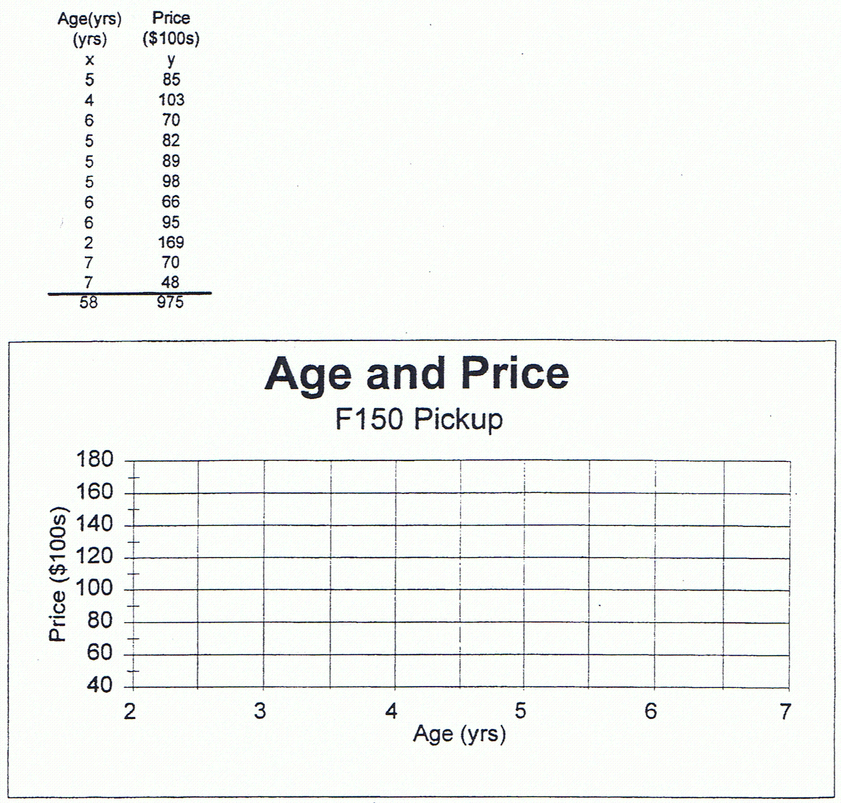

For the next two problems construct a scatterplot, find the value of the linear correlation coefficient r, find the critical value of r from Table A – 5 by using a = 0.05, and determine whether there is a linear correlation between the two variables.

#14 p.503.
The table below lists the numbers of audience impressions ( in hundreds of millions) listening to songs and the corresponding numbers of albums sold (in hundreds of thousands) . The number of audience impressions is a count of the number of times people have heard the song. Does it appear that album sales are affected very strongly by the number of audience impressions?

Audience impressions | 28 | 13 | 14 | 24 | 20 | 18 | 14 | 24 | 17
Albums sold | 19 | 7 | 7 | 20 | 6 | 4 | 5 | 25 | 12

- find the regression equation and the linear correlation coefficient. Determine if there is a linear correlation between the number of audience impressions and the number of albums sold.

Ho:______________
H₁:______________
test statistic:________________
critical value(s):___________________
decision:______________________
conclusion:

b) Find the best predicted number of albums sold for a song with 20 ( hundred millions) audience impressions.

#10 p.502 – Use table A-5 to find a critical value..
- Use a scatterplot and the linear correlation coefficient r to determine whether there is a correlation between the two variables.

x | 0 | 3 | 3 | 1 | 4
y | 1 | 7 | 2 | 5 | 5

Ho:______________
H₁:______________
critical value:__________________
test statistic:________________
decision:______________________
conclusion:

using the given 5 pairs of points find the equation of the regression line.

  - find the best predicted value for y when x = 4.
Common Errors Involving Correlation

- It is wrong to conclude that correlation implies causality
- Do not extrapolate your data, stay within the range of the available data.
- A regression equation based on the old data is not necessarily valid now.
- Don’t make predictions about a population that is different from a population from which the sample data were drown.

